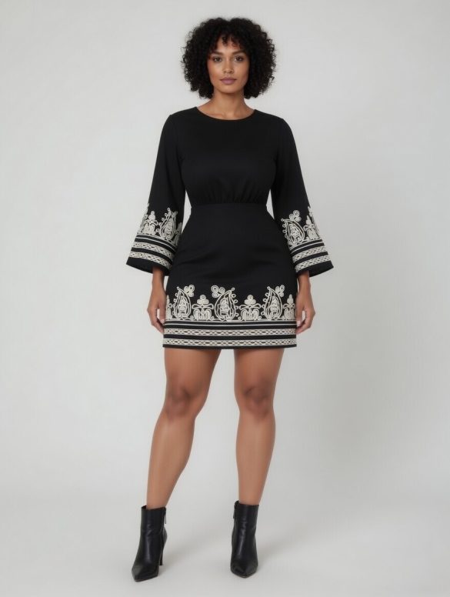

RAW Prompt:

make a clear detail like 100% detail about the dress patten and cloth quality, I attached the dress image almost all angle like 360 Degree, when i use to create the pose in all angel pose so i want exate patten not to chang the dress patten. because the original physical dress was not to cheange when the ai image generate in multiple pose like fornt, left side, right side, back side, so create based on the all above the fact. create prompt

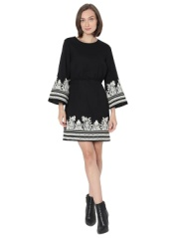

1. above 2000rs,

VERO Moda Above The Knee Fit and Flare Dress for Women

https://amzn.to/3OjibTt

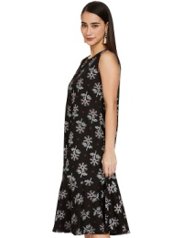

2. Above 700,

Amazon Brand - Myx Women's Rayon Knee-Length A-Line Dress

(Available in Plus Sizes)

https://amzn.to/41bRa7y

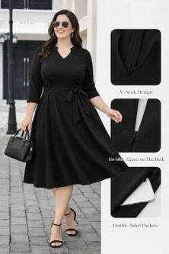

3. Above 800Rs,

Women's Plus Size Summer Wear Midi Dresses

https://amzn.to/4tobTke

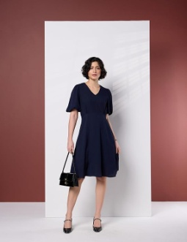

4. above 1600rs,

Symbol Premium Women's Fit & Flare Dress

(Below Knee Length | Stylish | Back Bow Tie) (Available in Plus Sizes)

https://amzn.to/3O3k1aT

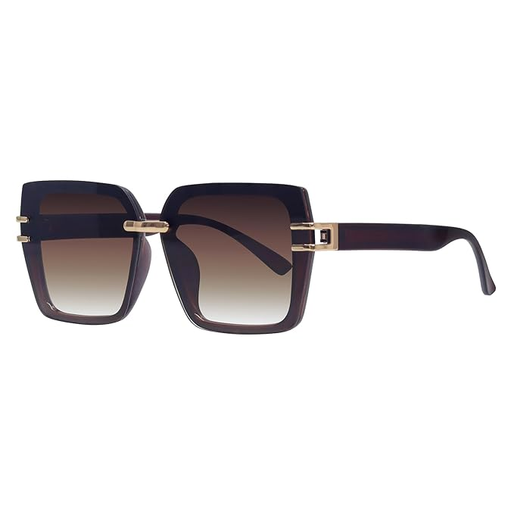

1. above 500rs,

HASHTAG EYEWEAR Stylish Square Sunglasses for Women https://amzn.to/4sgKwb8

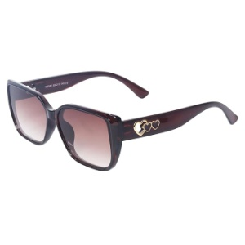

2. Above 800,

HASHTAG EYEWEAR Eye wear HASHTAG EYEWEAR UV Protected Sunglasses, Fashionable Eyewear |Women

https://amzn.to/4snugVW

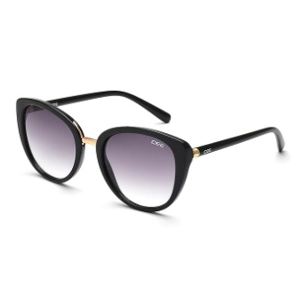

3. Above 1500rs,

DEE 100% UV Protected Sunglasses | Women | Cat Eye |

https://amzn.to/3NH1y43

-----------------------------------------------------

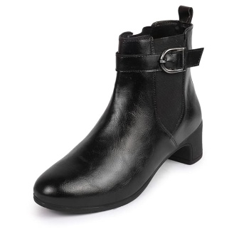

1. above 1,400rs,

FAUSTO Women Flared Heel Boots

https://amzn.to/3QgJFcW

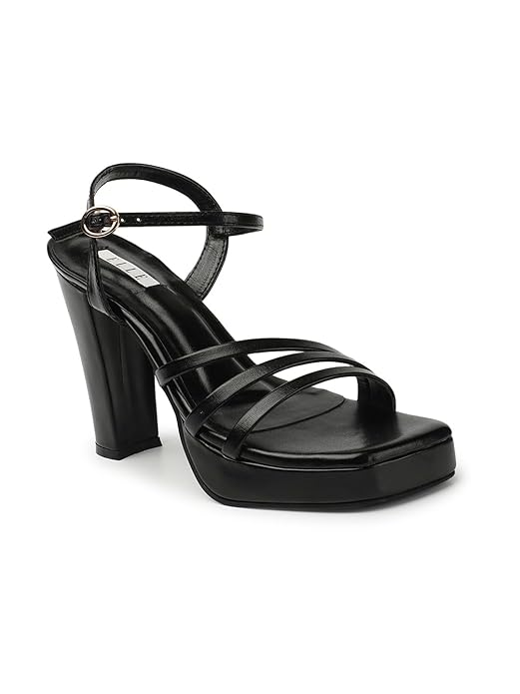

2. above 1300rs,

ELLE Women's Stylish and Elegant High Block Heels Fashion sandals

https://amzn.to/4v8sF8V

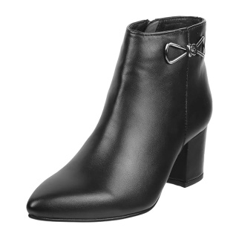

3. above 2.500rs,

Metro Women's Faux Leather Fashionable Trendy Ankle Boots

https://amzn.to/4sax3Bu

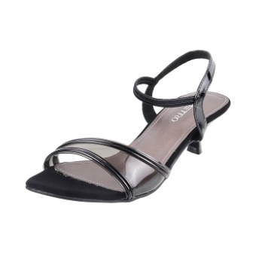

4.Above 1000rs,

Metro Women Synthetic Sandals

https://amzn.to/4m9ox4d

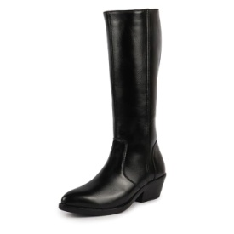

5. above 2500rs,

FAUSTO Women Flared Heel Boots

https://amzn.to/4e0U6ew

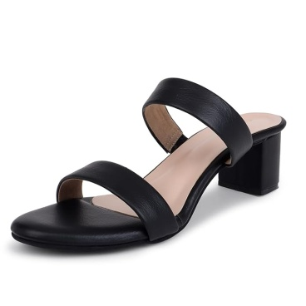

6. Above 800rs,

TRASE Block Heels Sandals For Women

https://amzn.to/47A56vG

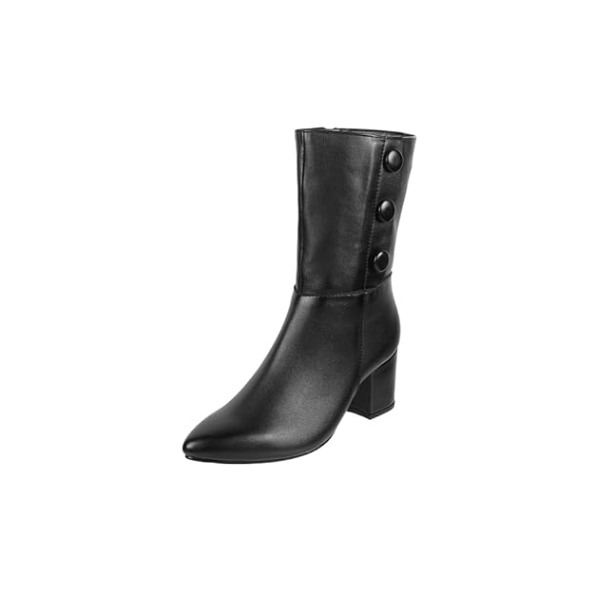

7. above 2600,

Metro Women Synthetic Block Heel Calf-Length Chukka Boot

https://amzn.to/4s8hydj

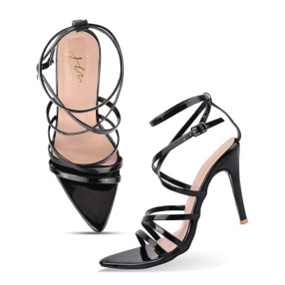

8. Above 600rs

JM LOOKS Women's Strappy Heels For Women

https://amzn.to/4dL2BKX

-----------------------------------------------------------------------

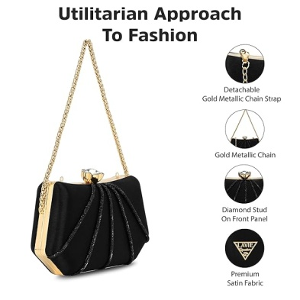

1. above 1200rs, Lavie Signature Women's Akron Handle Framed Clutch https://amzn.to/3Qj8pkM

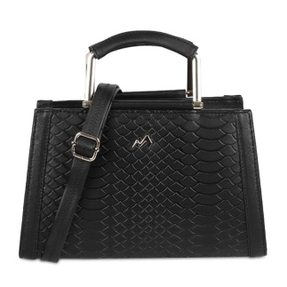

2. above 1100rs,

Metro Women Textured Top-Handle Bag

https://amzn.to/4tjVrBE

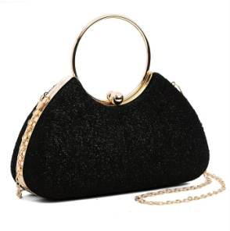

3.above 800rs,

INOVERA (LABEL) Hand Clutches for Women and Girls

https://amzn.to/4e2cFyZ

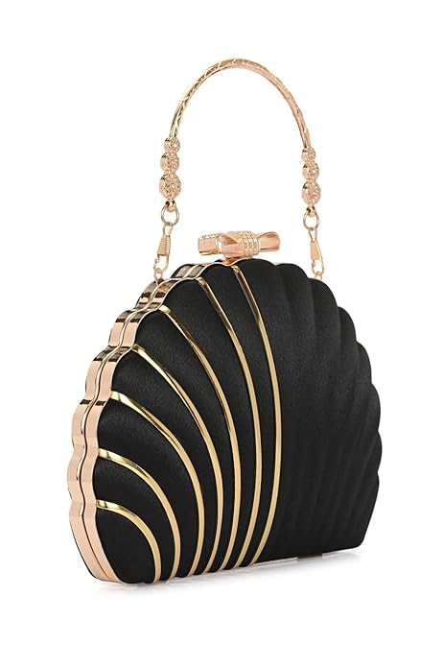

4.Above 700Rs,

TOOBA Girl's Black Handcrafted Beautiful Bling Box Clutch Bag for Womens

https://amzn.to/47Jrl2i

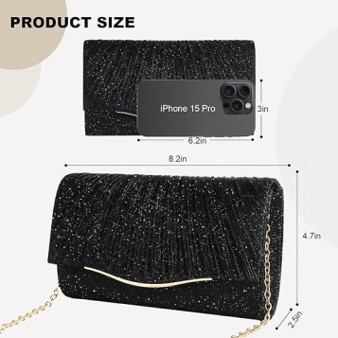

5. Above 400rs

Lyrovo Clutch Purse for Women Formal Dressy Evening

https://amzn.to/4mbkYL2

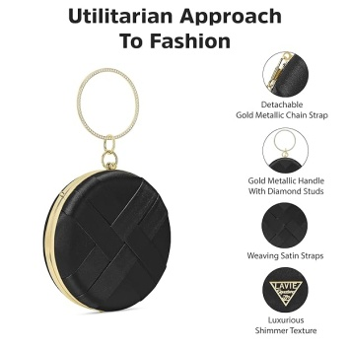

6. Above 1200rs,

Lavie Signature Women's Orem Circle Frame Clutch

https://amzn.to/4m8elJn

Prompt
A slim-fit short black dress with exact embroidery detailing, knee-length above the knee, made of soft lightweight woven fabric (viscose or rayon-like texture), matte finish, smooth drape, no shine.
Dress color: deep solid black.
Design structure:
- Round neckline, clean and minimal, no collar.
- Three-quarter bell sleeves (flared sleeves), loose and flowing.
- Waistline slightly cinched with elastic gathering, creating a soft natural drape.
- Straight silhouette, slightly relaxed fit (not bodycon).
Embroidery (STRICTLY PRESERVE EXACT PLACEMENT AND STYLE):
- Off-white / ivory thread embroidery.
- Intricate paisley and floral motifs.
Sleeves:
- Heavy embroidery starting from mid-forearm to sleeve hem.
- Includes paisley motifs and horizontal decorative bands near the edge.
- Multiple parallel embroidered lines at sleeve border.
Hem (bottom of dress):
- Thick embroidered border across entire hemline.
- Repeating paisley motifs evenly spaced.
- Horizontal stripe patterns layered above hem edge.
Back:
- Small vertical keyhole opening at upper back with button closure.
- No embroidery on upper back.
- Embroidery only continues at sleeve ends and bottom hem.
Fabric behavior:
- Soft flowy drape.
- Natural folds around waist and skirt area.
- No stiffness, no glossy reflections.
make it symetricaly match the front and back paten in the cloth like seamless
Fit accuracy:
- Maintain exact embroidery scale, spacing, and alignment.
- Do NOT alter pattern size, density, or layout.
- Do NOT add extra decorations.
Model styling:
- Neutral expression.
- Minimal makeup.
- Short straight hair (bob cut).
- Black ankle boots.
Lighting:
- Soft studio lighting, neutral background (light grey or beige).
- High detail, fashion catalog photography style.
CRITICAL:
Ensure the embroidery pattern remains IDENTICAL across all generated poses.
Do not reinterpret, redesign, or stylize the embroidery.
Maintain pattern continuity from front → side → back views. left side profile view, body turned 90 degrees, head slightly facing forward, left side profile view, body turned 90 degrees, head slightly facing forward, right side profile view, body turned 90 degrees, head slightly facing forward, full back view, showing keyhole detail clearly, full back view, showing keyhole detail clearly, (no pattern distortion,
no extra embroidery,
no missing embroidery,
no color change,
no shiny fabric,
no satin, no silk gloss,
no redesign,
no asymmetry,
no random patterns,
no texture noise,
no blur,
no inconsistent sleeve design,
no incorrect hem border,
no added accessories on dress), same outfit consistency, same garment identity, multi-view consistency, fashion catalog continuity.
A confident female fashion model standing in an elegant luxury clothing showroom interior, wearing a stylish modern outfit (fitted top with textured fabric and a layered designer skirt with fine details and soft materials). The environment features warm ambient lighting, premium décor, polished floors, and minimalist high-end display elements. The camera perspective acts like a mirror from the model’s point of view. The model is gracefully observing herself, expressing confidence and satisfaction with the outfit fitting. She performs natural fashion-check movements: front pose, slight turn to left back, right back, and full back view. Her head and body maintain anatomically correct, realistic motion with smooth posture transitions. Cinematic lighting with soft highlights and shadows, showroom spotlight effect, high detail fabric texture, realistic skin tones, depth of field, 4K fashion photography style, editorial magazine quality. Mood: confident, elegant, premium fashion presentation. Composition: full-body framing, balanced symmetry, clean background, focus on outfit and posture. maintain the original cloth patern not morpthe cloth or model shape, not to create abnormal human action and the cloth flow. the cloth embroiders and the paten will symmetrically match her front and back.

